

|  |
| --- |
| **PR Activity – June 2021** |



**PR Activity June 2021**

|  |
| --- |
| Highlights of the month:   1. We have received total 47 coverages- 25 print and 22 online. 2. We have received 2 poultry magazines, 21 SIPM coverage, and 19 Suguna foods coverage in total.   3.   The press release on the topic “Chicken enriches immunity by reducing fatigue” was carried across publications pan India.  4.    We have received two trade magazines coverage for the article on summer management techniques for poultry farming.  5. Our influencer Ms. Urvi Arjan Gajra, wrote on the topic vitamin D deficiency and the need to consume chicken and eggs is been published in Femina Tamil.  6. Puthiya Thalaimurai Channel has carried an interview with our influencer Ms. Muthulakshmi, who has spoken the importance of consuming food containing Vitamins. |

Name of the Media: Amrit India

Date: 19.06.2021

Region: Delhi

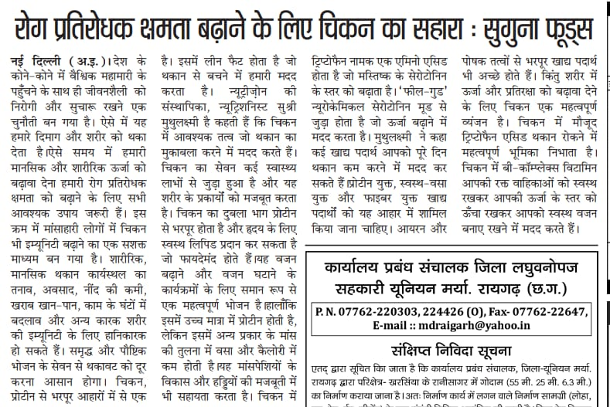

Name of the Media: Deshbandhu

Date: 19.06.2021

Region: Delhi

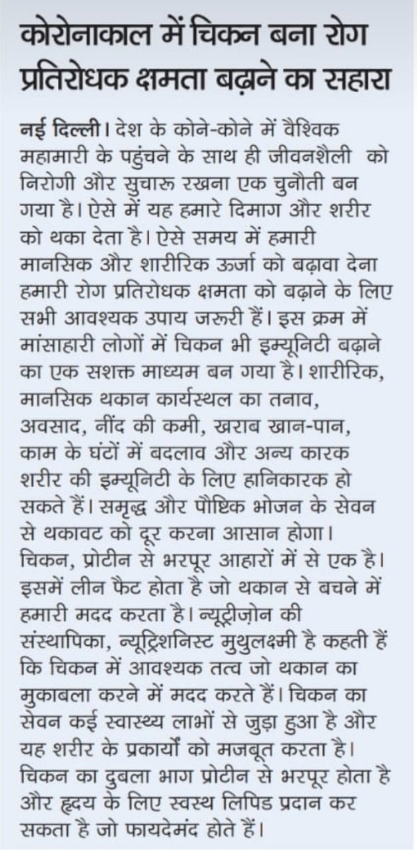

Name of the Media: Gurgaon Today

Date: 19.06.2021

Region: Delhi

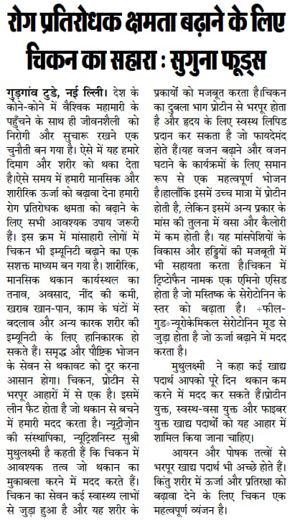

Name of the Media: Shabad Vani Samachar

Date: 19.06.2021

Region: Delhi

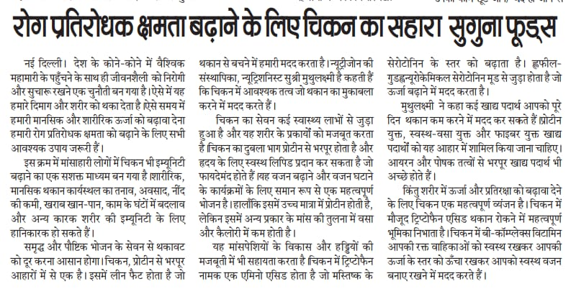

Name of the Media: Uttar Prahari

Date: 19.06.2021

Region: Delhi

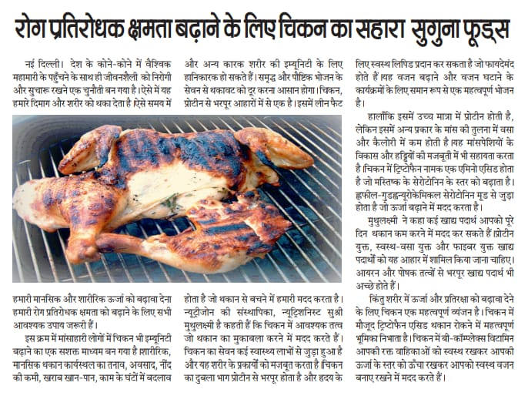

Name of the Media: Veer Arjun

Date: 19.06.2021

Region: Delhi

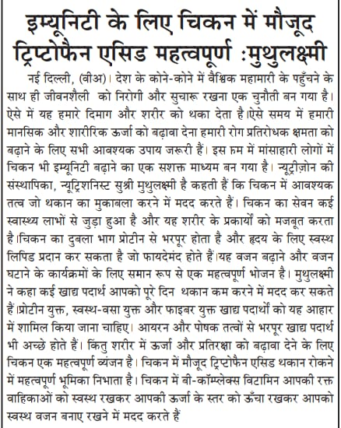

Name of the Media: The Global Times

Date: 21.06.2021

Region: Maharastra

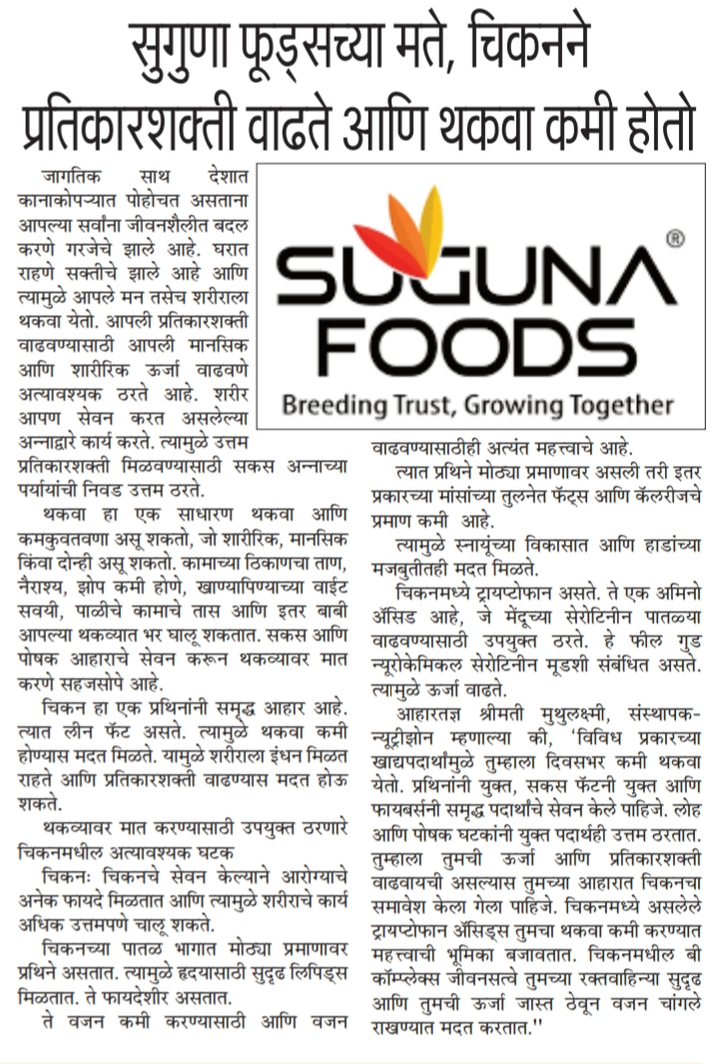

Name of the Media: Deshbandu

Date: 22.06.2021

Region: Delhi

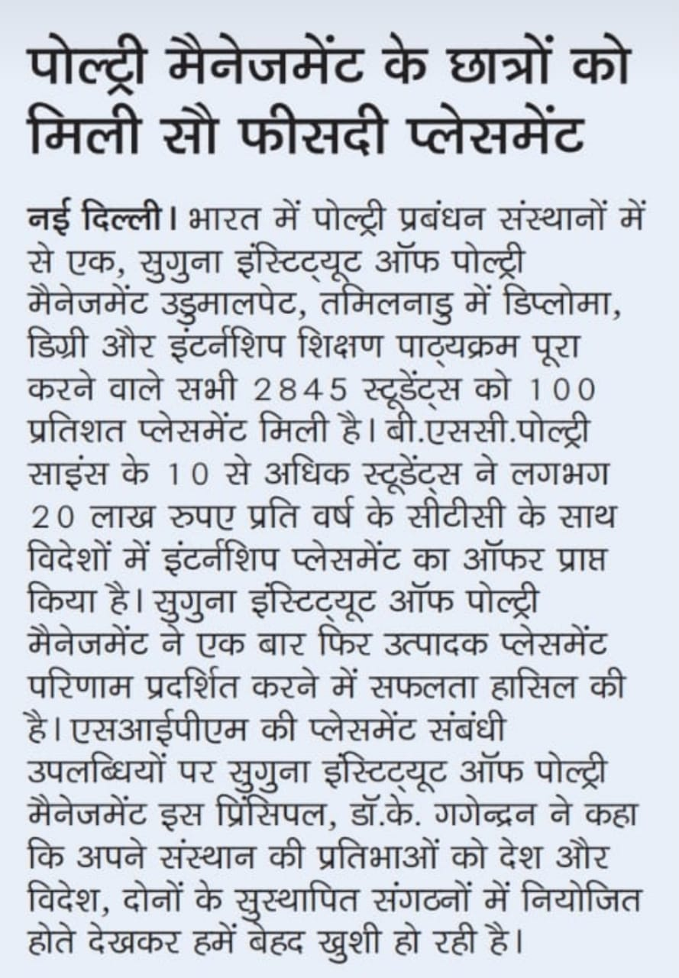

Name of the Media: Gurgaon Today

Date:22.06.2021

Region: Delhi

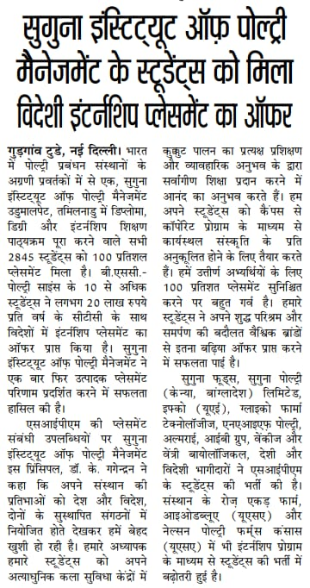

Name of the Media: Navbharath

Date: 22.06.2021

Region: Maharastra

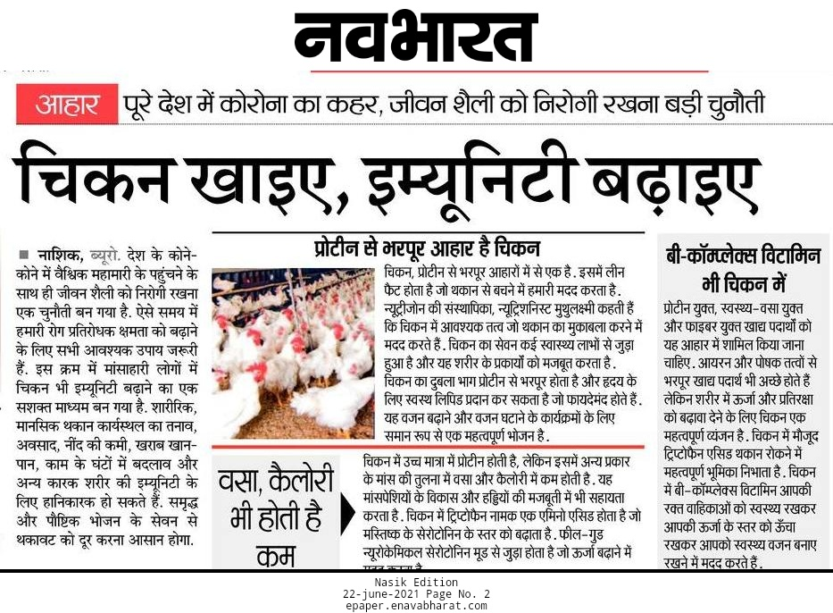

Name of the Media: Uttar Prahari

Date: 22.06.2021

Region: Delhi

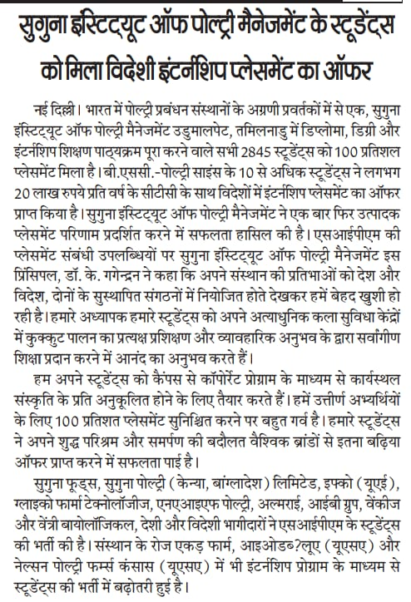

Name of the Media: Veer Arjun

Date: 22.06.2021

Region: Delhi

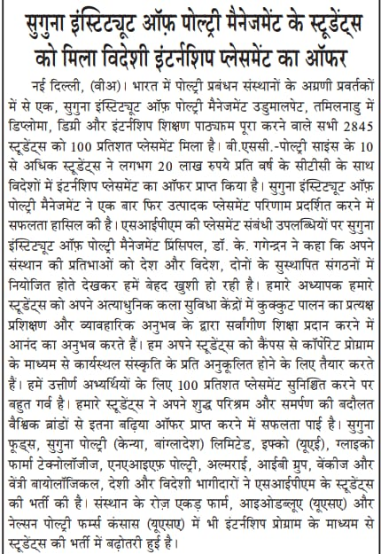

Name of the Media: Amrit India

Date: 22.06.2021

Region: Delhi

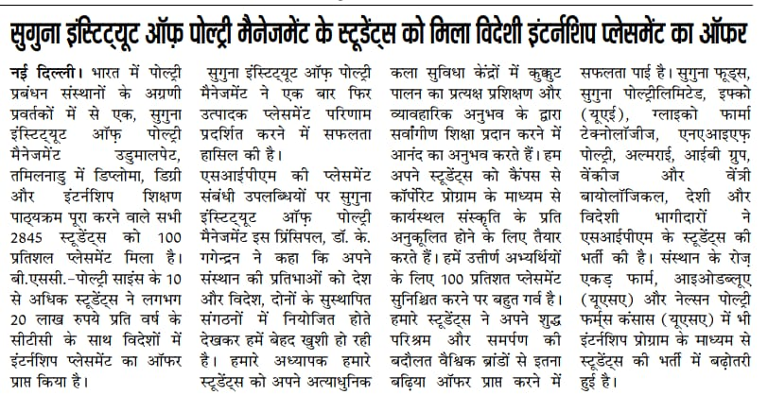

Name of the Media: Punjab Kesari

Date: 23.06.2021

Region: Delhi

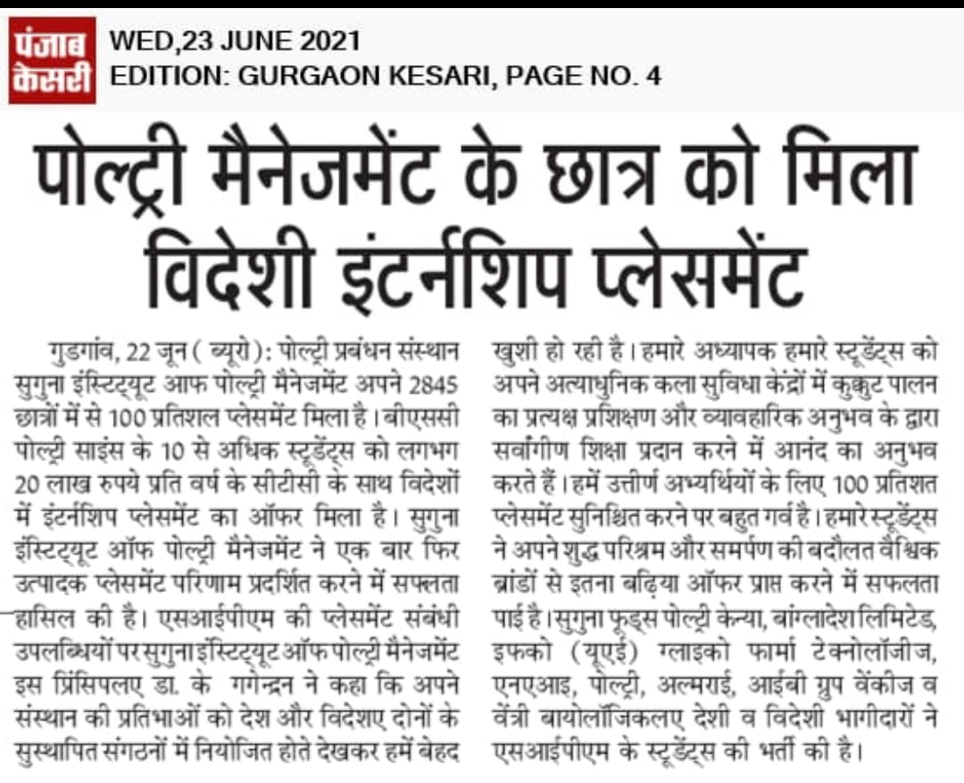

Name of the Media: Shabad Vani

Date: 23.06.2021

Region: Delhi

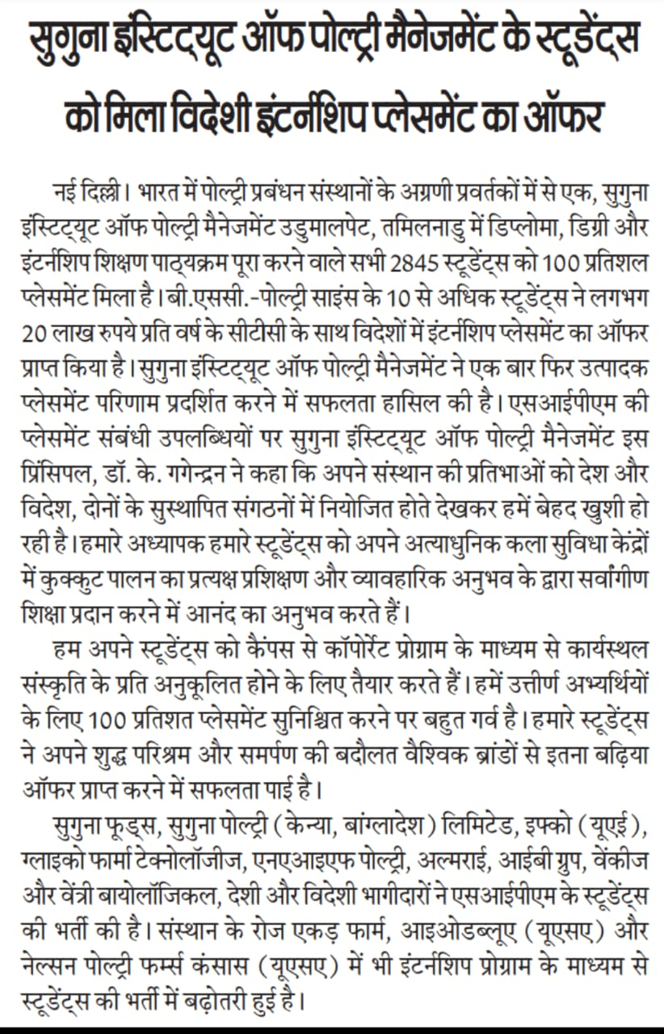

Name of the Media: Udayavahini

Date: 23.06.2021

Region: Karnataka

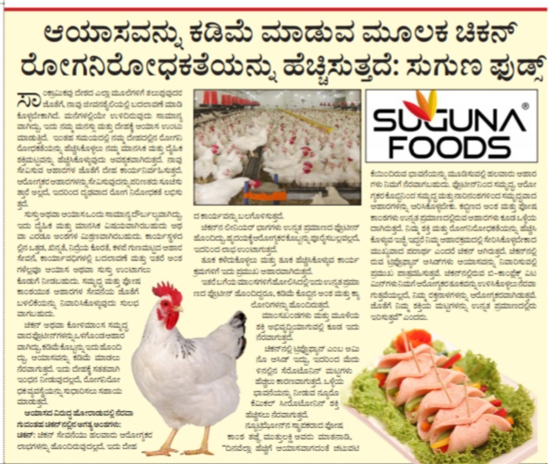

Name of the Media: Subhashita

Date: 24.06.2021

Region: Karnataka

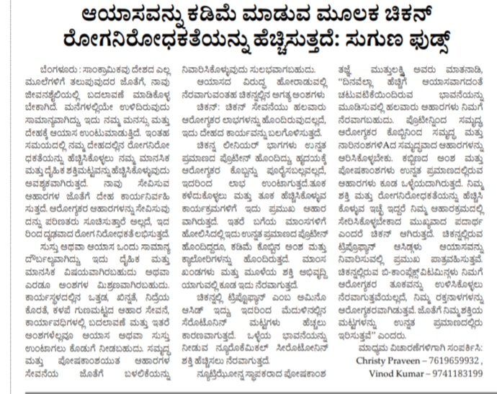

Name of the Media: The Global TImes

Date: 24.06.2021

Region: Maharastra

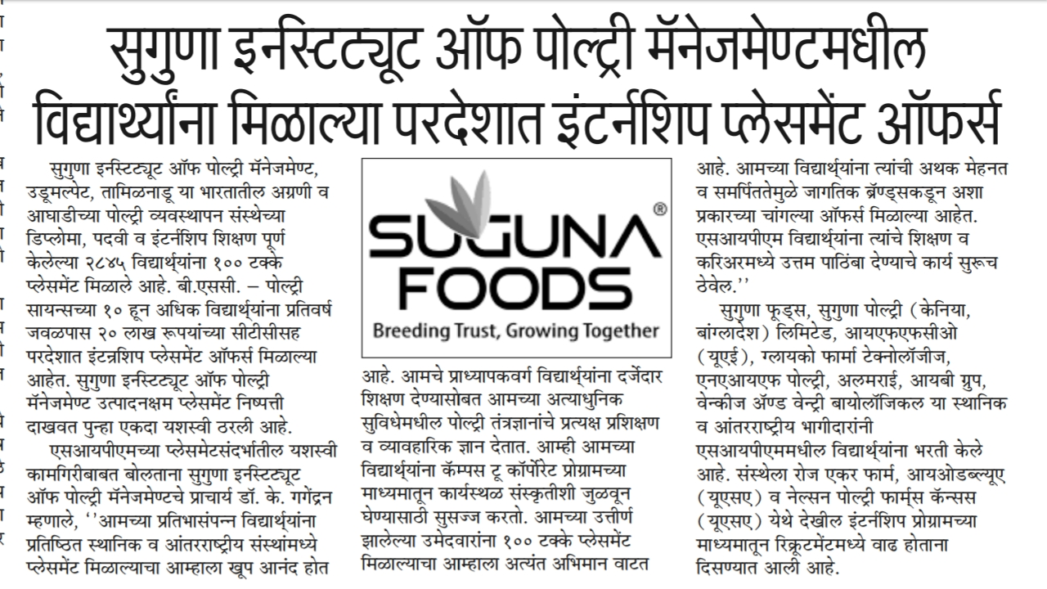

Name of the Media: Manam

Date: 26.06.2021

Region: Andhra Pradesh

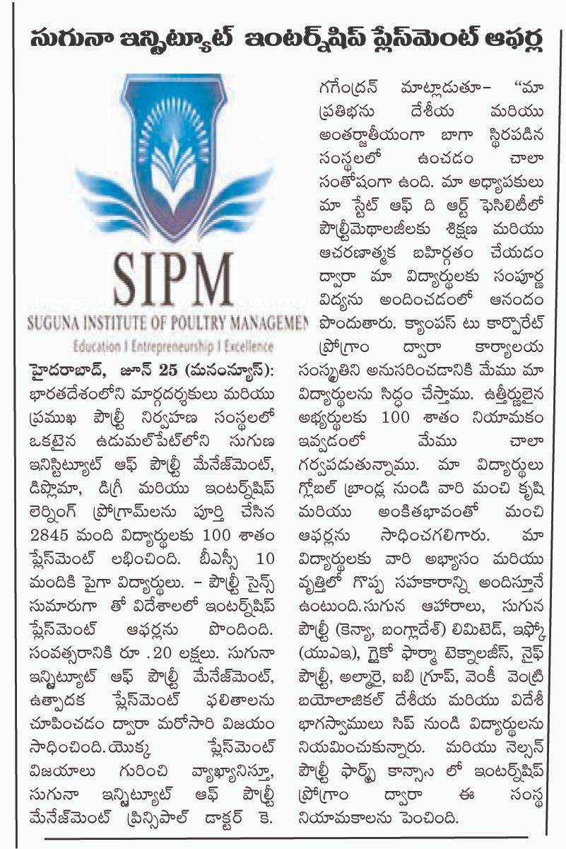

Name of the Media: Niga

Date: 26.06.2021

Region: Andhra Pradesh

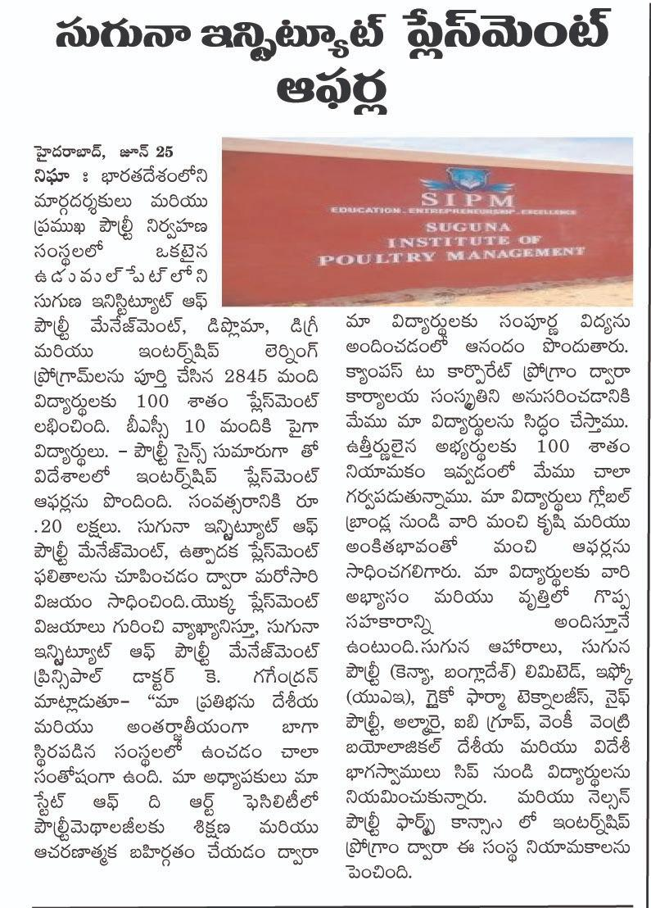

Name of the Media: Telugu Prabha

Date: 26.06.2021

Region: Andhra Pradesh

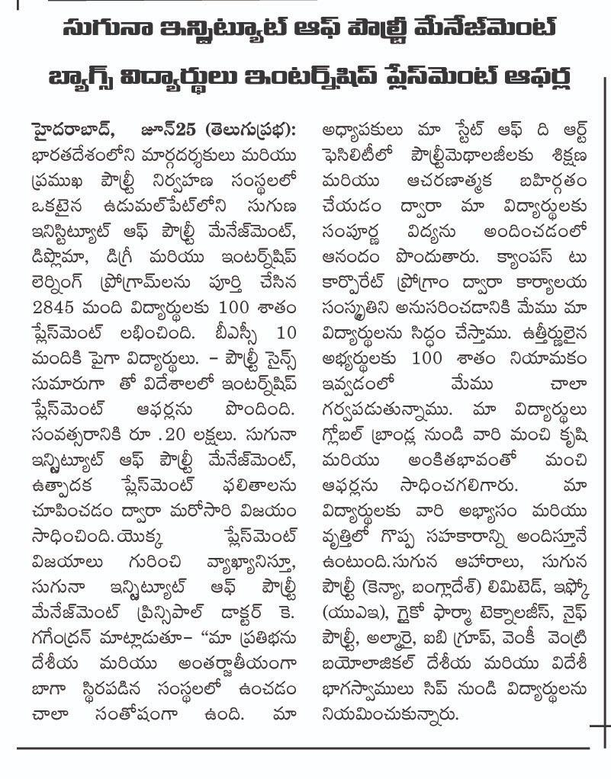

Name of the Media: Toli Velugu

Date: 26.06.2021

Region: Andhra Pradesh

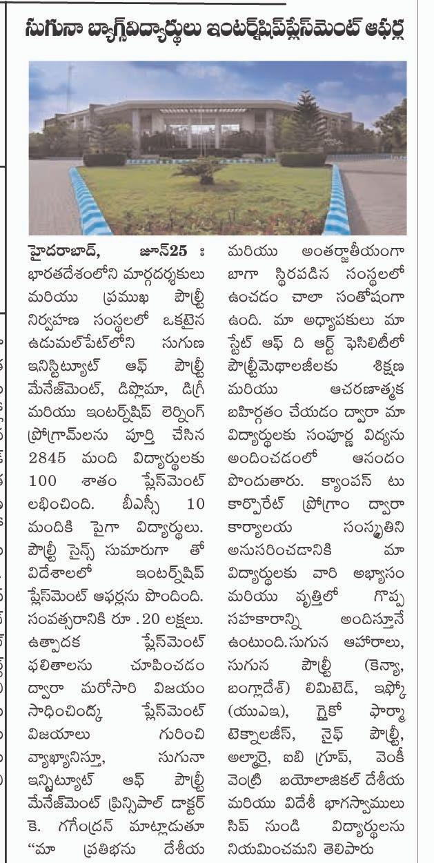

Name of the Media: Sanje Samaya

Date: 28.06.2021

Region: Karnataka

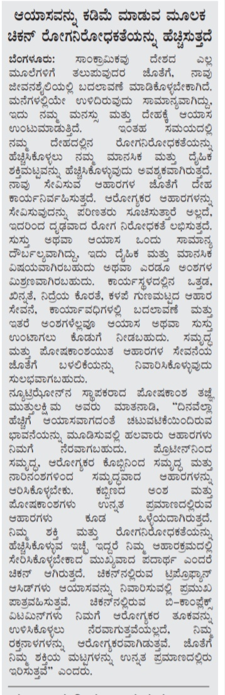

Trade Magazines:

Magazine Name: Poultry Fortune

Date: 08.06.2021

Region: All India

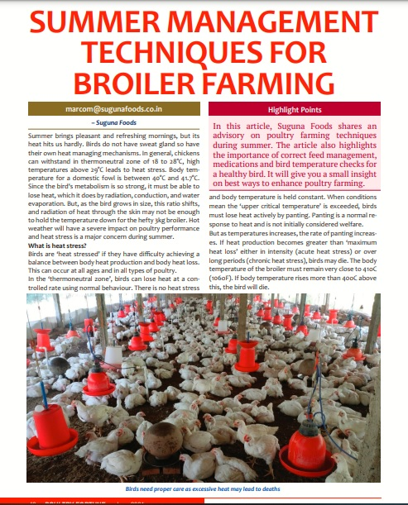

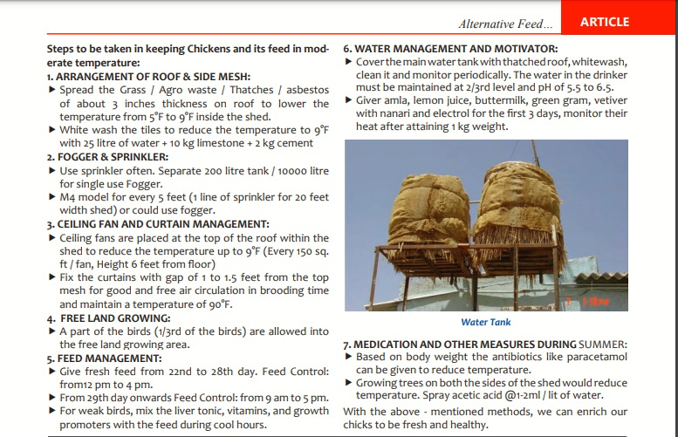

Magazine Name: Poultry World

Date: 22.06.2021

Region: All India

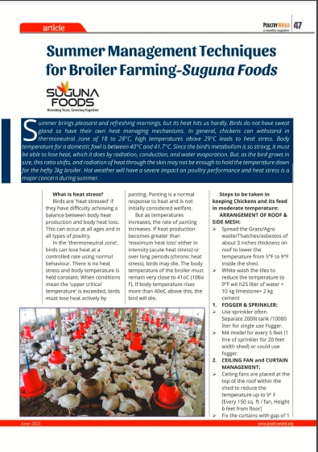

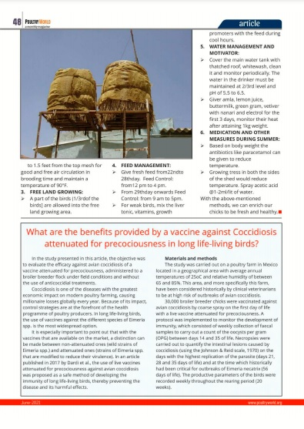

**Online Coverages:**

|  |  |  |  |  |
| --- | --- | --- | --- | --- |
| 1 | 09.06.2021 | Hot news express | Try some sunshine vitamin to beat Covid | https://hotnewsexpress.com/2021/06/09/try-some-sunshine-vitamin-to-beat-covid-19/ |
| 2 | 10.06.2021 | B4U media | Try some sunshine vitamin to beat Covid | http://www.b4umedia.in/?p=234081 |
| 3 | 18.06.2021 | City Air News | Chickens enriches immunity by reducing fatigue | https://www.cityairnews.com/content/chickens-enriches-immunity-by-reducing-fatigue |
| 4 | 18.06.2021 | Media Bulletins | Chickens enriches immunity by reducing fatigue | http://mediabulletins.com/business-world/chickens-enriches-immunity-by-reducing-fatigue-says-suguna-foods/ |
| 5 | 18.06.2021 | Digital Media9 | Chickens enriches immunity by reducing fatigue | <https://digitalmedia9.com/business/chickens-enriches-immunity-by-reducing-fatigue-says-suguna-foods/> |
| 6 | 18.06.2021 | Business News this week | Chickens enriches immunity by reducing fatigue | <http://businessnewsthisweek.com/business/chickens-enriches-immunity-by-reducing-fatigue-says-suguna-foods/> |
| 7 | 18.06.2021 | Apensha-  sandesh | Chickens enriches immunity by reducing fatigue | <https://apekshasandesh.com/chickens-enriches-immunity-by-reducing-fatigue> |
| 8 | 18.06.2021 | Femina tamil | Vitamin-D deficiency in patients recovered from COVID-19 | <https://www.femina.in/tamil/health/diet/vitamin-d-deficiency-in-patients-recovered-from-covid-19_-2583.html> |
| 9 | 19.06.2021 | This week India | Chickens enriches immunity by reducing fatigue | <https://thisweekindia.news/chickens-enriches-immunity-by-reducing-fatigue-says-suguna-foods/> |
| 10 | 19.06.2021 | India Press | Chickens enriches immunity by reducing fatigue | <http://www.india-press-release.com/press/press_featured/regular/2889/chickens-enriches-immunity-by-reducing-fatigue--says-suguna-foods> |
| 11 | 22.06.2021 | Apeksha -sandesh | Students from Suguna institute of poultry management bags oversees internship placement offers | <https://apekshasandesh.com/students-from-suguna-institute-of-poultry-management-bags-oversees-internship-placement-offers> |
| 12 | 22.06.2021 | City Air News | Students from Suguna institute of poultry management bags oversees internship placement offers | <https://www.cityairnews.com/content/students-from-suguna-institute-of-poultry-management-bags-oversees-internship-placement-offers> |
| 13 | 22.06.2021 | India Press Release | Students from Suguna institute of poultry management bags oversees internship placement offers | <http://www.india-press-release.com/press/press_featured/regular/2897/students-from-suguna-institute-of-poultry-management-bags-oversees-internship-placement-offers> |
| 14 | 22.06.2021 | Lifestyle RD times | Chickens enriches immunity by reducing fatigue | <https://lifestyle.rdtimes.in/chickens-enriches-immunity-by-reducing-fatigue-says-suguna-foods/> |
| 15 | 22.06.2021 | Indian sentinel | Chickens enriches immunity by reducing fatigue | <https://indiansentinel.in/chickens-enriches-immunity-by-reducing-fatigue-says-suguna-foods/> |
| 16 | 22.06.2021 | Health RDTimes | Chickens enriches immunity by reducing fatigue | <https://health.rdtimes.in/chickens-enriches-immunity-by-reducing-fatigue-says-suguna-foods/> |
| 17 | 22.06.2021 | Content Media solutions | Students from Suguna institute of poultry management bags oversees internship placement offers | <https://contentmediasolution.com/business/students-from-suguna-institute-of-poultry-management-bags-oversees-internship-placement-offers/> |
| 18 | 22.06.2021 | Edu.RDTimes | Students from Suguna institute of poultry management bags oversees internship placement offers | <https://edu.rdtimes.in/students-from-suguna-institute-of-poultry-management-bags-oversees-internship-placement-offers/> |
| 19 | 22.06.2021 | Media bulletins | Students from Suguna institute of poultry management bags oversees internship placement offers | <http://mediabulletins.com/education/students-from-suguna-institute-of-poultry-management-bags-oversees-internship-placement-offers/> |
| 20 | 22.06.2021 | Business news this week | Students from Suguna institute of poultry management bags oversees internship placement offers | <http://businessnewsthisweek.com/education/students-from-suguna-institute-of-poultry-management-bags-oversees-internship-placement-offers/> |
| 21 | 23.06.2021 | Emedialine | Chickens enriches immunity by reducing fatigue | <https://emedialine.com/archives/60541> |
| 22 | 30.06.2021 | Puthiya Thalaimurai Channel | Importance of vitamins in eggs and chickens | <https://youtu.be/HnlsUZ0Yolc> |